EAST GWILLIMBURY DUNSMUIR MEMORIAL TOURNAMENT April 4-7, 2019

Team Name:
Association:
Association Website:
Affiliation (OMHA, Alliance etc.…):
Team Colours (Home/Away):
Team Contact:
Address:
Postal Code:
Telephone (Primary):
Telephone (Secondary):
Email Address:
Category (e.g. Atom, Peewee…)
Please indicate Minor or Major

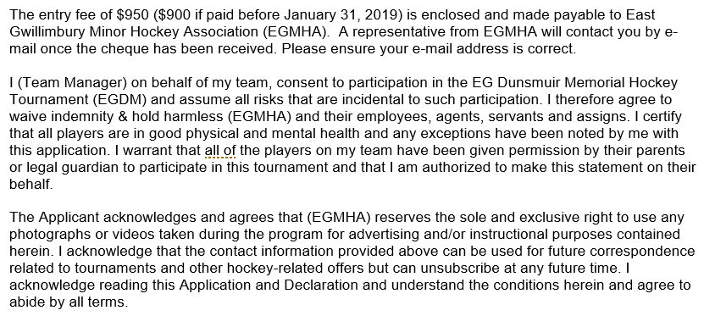

________________________________
SIGNATURE:

________________________________ ________________________________
Printed Name Date

